Deep Learning for Enhanced Channel Estimation in Future Wireless Communication Systems

A PROJECT REPORT

Submitted by

PAWAN S : 211520106063

HARSH BHUSHAN M : 211520106031

ABDUL RAHMAAN A : 211520106002

In partial fulfillment of the award of the degree of

BACHELOR OF ENGINEERING

IN

ELECTRONICS AND COMMUNICATION ENGINEERING

PANIMALAR INSTITUTE OF TECHNOLOGY ANNA UNIVERSITY, CHENNAI-600025

APRIL 2024

ANNA UNIVERSITY, CHENNAI-600025

BONAFIDE CERTIFICATE

Certified that this project report “Deep Learning for Enhanced Channel Estimation in Future Wireless Communication Systems” is the bonafide work of PAWAN S.(211520106063), HAR63SH BHUSHAN M.(211520106031) AND ABDUL RAHMAAN A . (211520106002)who carried out the project work under my supervision.

**_______________________ ______________________**

SIGNATURE SIGNATURE

DR.S. SATHYA PRIYA M.E., PH.D., DR.T.JAYANTHI

HEAD OF THE DEPARTMENT PRINCIPAL

ELECTRONICS AND COMMUNICATION ELECTRONICS AND COMMUNICATION

ENGINEERING ENGINEERING

PANIMALAR INSTITUTE OF TECHNOLOGY PANIMALAR INSTITUTE OF TECHNOLOGY

No.391, Bangalore Trunk Road, No.391, Bangalore Trunk Road,

Varadharajapuram, Poonamallee, Varadharajapuram, Poonamallee,

Chennai–600123. Chennai-600123

Certified that the above students have attended viva voce during the exam held on___________

at Panimalar Institute of Technology, Chennai–600123.

INTERNAL EXAMINER EXTERNAL EXAMINER

ACKNOWLEDGEMENT

We have made efforts to complete this project. However, it would not have been possible without the kind support and help of many individuals and our institution. We are using this opportunity to express our gratitude to everyone who supported us throughout the course of this final-year project.

Our sincere thanks to Our Honourable Founder and Chairman, Late. Col. Dr. JEPPIAAR M.A., Ph.D., for educating us in his premier institution. We would like to express special gratitude and thanks to Our Beloved Secretary and Correspondent, Dr. P. CHINNADURAI, M.A., Ph.D., for providing us with such a platform to complete our project.

We express warm thanks to Our Directors Mrs. C. VIJAYARAJESWARI, Mr. C. SAKTHI KUMAR, M.E and Mrs. SARANYA SREE SAKTHI KUMAR, B.E for their support and valuable guidance. We are sincerely grateful to Our Principal, Dr. T. JAYANTHY, M.E., Ph.D., for sharing her illuminating views on some issues related to our project.

We are highly indebted to Our Head of the Department, Dr. S. SATHA PRIYA, M.E., Ph.D., for her guidance and constant supervision as well as for providing necessary information regarding the project and also for her support in completing the project.

We are thankful to our Project Coordinator Dr.R.PRATHIPA and our Internal Guide, Dr. T. JAYANTHI, for their aspiring guidance, invaluably constructive criticism, and friendly advice during the project work.

We would also like to thank all our department staff who provided us with the facilities required and conducive conditions for our project. Our thanks and appreciation also go to our friends who have willingly helped us out with their abilities.

Last but not least we would like to express our gratitude to our parents for their kind cooperation and encouragement which helped us in the completion of this project.

**ABSTRACT**

This system delves into the realm of Deep Learning (DL) for channel estimation, focusing on crucial aspects such as DL model selection, training set acquisition, and the design of the RESNET50 architecture. With the increasing integration of automated services, machines, vehicles, and sensors, DL is poised to become a predominant paradigm in 6G era channel estimation. The system advocates for advanced DL techniques to address diverse challenges, including various frequency bands, wireless resources, and geographical environments. It highlights transfer learning for training DL models and explores federated learning for collaborative task accomplishment. This comprehensive system aims to guide MIMO communication researchers in integrating DL into their wireless channel estimation applications. In addition to model selection and training set acquisition, the system emphasizes the importance of optimizing hyperparameters and incorporating domain knowledge into DL architectures for improved performance. It also underscores the significance of continuous adaptation and retraining to account for dynamic changes in wireless environments. By providing a roadmap for integrating DL into MIMO communication systems, this system seeks to accelerate the development of robust and efficient channel estimation techniques for next-generation wireless networks.

**TABLE OF CONTENTS**

**TITLE**

**CHAPTER 1**

**INTRODUCTION------------------------------------------------------------------------------------------------2-8**

**1.1:INTRODUCTION-----------------------------------------------------------------------------------------2-4**

**1.2:PROBLEM STATEMENT-------------------------------------------------------------------------------4-5**

**1.3:SCOPE-------------------------------------------------------------------------------------------------------5-8**

**CHAPTER 2**

**LITERATURE SURVEY----------------------------------------------------------------------------------------9-19**

**2.1:INTRODUCTION------------------------------------------------------------------------------------------9-9**

**2.2:SURVEY------------------------------------------------------------------------------------------------------10-19**

**CHAPTER 3**

**CURRENT SCENARIO AND PROPOSED SYSTEM----------------------------------------------------20-27**

**3.1:INTRODUCTION------------------------------------------------------------------------------------------20-20**

**3.2:EXISTING SYSTEM--------------------------------------------------------------------------------------21-23**

**3.3:PROPOSED SYSTEM------------------------------------------------------------------------------------23-27**

**CHAPTER 4**

**SYSTEM DESIGN------------------------------------------------------------------------------------------------28-30**

**4.1:PROPOSED BLOCK DIAGRAM----------------------------------------------------------------------28-28**

**4.2:FLOW CHART---------------------------------------------------------------------------------------------29-29**

**4.3:ARCHITECTURE DIAGRAM-------------------------------------------------------------------------30-30**

**CHAPTER 5**

**HARDWARE SPECIFICATION------------------------------------------------------------------------------31-32**

**5.1:HARDWARE-----------------------------------------------------------------------------------------------31-31**

**5.2:SPECIFICATION-----------------------------------------------------------------------------------------31-32**

**CHAPTER 6**

**SOFTWARE SPECIFICATION-------------------------------------------------------------------------------33-74**

**6.1:SOFTWARE REQUIREMENTS-----------------------------------------------------------------------33-34**

**6.2:SOFTWARE SPECIFICATION------------------------------------------------------------------------35-45**

**CHAPTER 7**

**RESULTS-----------------------------------------------------------------------------------------------------------46-50**

**CHAPTER 8**

**CONCLUSION AND FUTURE SCOPE--------------------------------------------------------------------51-55**

**REFERENCES-------------------------------------------------------------------------------------------55-60**

**LIST OF TABLES**

**TABLE--------------------------------------------------------------------------------------------------------------35-36**

**1.1:POLLS OR TRENDY DATA MINING METHODS(2013-2016)-----------------------------------35**

**1.2:CELEBRITY OF MATLAB IN DATA MINING(2010-2016)---------------------------------------36**

**LIST OF FIGURES**

**4.1:PROPOSED BLOCK DIAGRAM------------------------------------------------------------------------28**

**4.2:FLOW CHART-----------------------------------------------------------------------------------------------29**

**4.3:ARCHITECTURE DIAGRAM:--------------------------------------------------------------------------30**

**10.0:CASE OF GRAPHICAL UI------------------------------------------------------------------------------?**

**11.0:PROPERTY INSPECTOR--------------------------------------------------------------------------------?\**

**12.0:AN EXAMPLE OF PROPERTY INSPECTOR FOR SLIDER BAR AXES--------------------?**

**13.0:AN EXAMPLE OF PROPERTY INSPECTOR FOR AXES---------------------------------------?**

**15.0:AN EXEMPLARY MENU CREATED IN MENU EDITOR---------------------------------------?**

**16.0:SIMPLE, GUI WITH READY-BUILT MENU--------------------------------------------------------?**

**CHAPTER I**

**INTRODUCTION**

* 1. **Introduction**

In the fast-evolving landscape of wireless communication systems, accurate channel estimation stands as a cornerstone for achieving reliable and efficient data transmission. As we progress towards the 6G era, characterized by unprecedented integration of automated services, machines, vehicles, and sensors, the demand for robust and adaptable channel estimation techniques escalates. In response to this, Deep Learning (DL) emerges as a promising paradigm, offering unparalleled capabilities in handling complex data patterns and optimizing system performance.

This system embarks on a journey into the realm of DL for channel estimation, emphasizing critical considerations such as model selection, training set acquisition, and architectural design. With a focus on the RESNET50 architecture, renowned for its depth and efficacy in image classification tasks, we seek to adapt and extend its principles to the domain of wireless communications. By harnessing DL's power, we aim to address the multifaceted challenges posed by diverse frequency bands, wireless resources, and geographical environments.

DL holds immense potential to revolutionize channel estimation methodologies, offering solutions that are not only accurate but also adaptable to dynamic network conditions. By leveraging advanced DL techniques, we can transcend the limitations of traditional methods and pave the way for enhanced communication systems in the 6G era.

One of the primary challenges in deploying DL for channel estimation lies in the selection of appropriate models that can effectively capture the underlying characteristics of wireless channels. In this regard, our system advocates for a thorough evaluation of various DL architectures, considering factors such as computational complexity, memory requirements, and scalability. The adoption of models like RESNET50 underscores our commitment to leveraging state-of-the-art techniques to achieve superior performance.

Furthermore, the acquisition of high-quality training data plays a pivotal role in the success of DL-based channel estimation systems. Given the vast variability in wireless environments, it is imperative to curate diverse and representative datasets that encompass a wide range of scenarios. Our system emphasizes the importance of data augmentation techniques and real-world measurements to enhance the robustness and generalization capabilities of DL models.

Transfer learning emerges as a key strategy for optimizing DL model training, enabling knowledge transfer from pre-trained models to specific channel estimation tasks. By leveraging features learned from relevant domains, we can expedite the convergence process and mitigate the need for large-scale labeled datasets. This approach not only reduces computational overhead but also enhances the adaptability of DL models across different deployment scenarios.

In the pursuit of collaborative and decentralized solutions, federated learning holds promise for distributed channel estimation tasks. By orchestrating model training across geographically dispersed nodes while preserving data privacy, federated learning offers a viable framework for collective knowledge aggregation. Our system explores the potential of federated learning in the context of channel estimation, highlighting its suitability for scenarios characterized by heterogeneous data sources and regulatory constraints.

In summary, this comprehensive system endeavors to serve as a guiding light for MIMO communication researchers seeking to embrace DL in their channel estimation applications. By advocating for advanced DL techniques and innovative methodologies, we aim to usher in a new era of intelligent and adaptive wireless communication systems, poised to meet the demands of the 6G landscape and beyond.

**1.2 Problem Statement**

Wireless communication systems are facing increasingly complex challenges in the 6G era, characterized by the integration of diverse technologies, high data rates, and stringent reliability requirements. One of the fundamental components of wireless communication systems is channel estimation, which plays a crucial role in optimizing transmission efficiency and ensuring reliable data delivery. However, traditional channel estimation methods often fall short in coping with the dynamic and heterogeneous nature of modern communication environments.

Existing channel estimation techniques, such as pilot-based methods and least squares estimation, rely on simplistic models and assumptions that may not accurately capture the complexities of real-world scenarios. These methods are often sensitive to factors like channel fading, interference, and mobility, leading to suboptimal performance in practical applications. Moreover, the escalating demand for high-speed and low-latency communication services necessitates more sophisticated and adaptive channel estimation techniques.

Furthermore, the proliferation of interconnected devices and emerging technologies introduces new challenges for channel estimation, such as the need to support diverse frequency bands, accommodate massive MIMO antennas, and mitigate interference from intelligent reflecting surfaces. Traditional methods may struggle to cope with these challenges, highlighting the need for more advanced and versatile solutions.

Deep Learning (DL) presents itself as a promising approach to address the shortcomings of traditional channel estimation methods. By leveraging the power of artificial neural networks, DL techniques have demonstrated remarkable capabilities in learning complex patterns and extracting features from large datasets. However, the integration of DL into wireless channel estimation systems poses its own set of challenges, including DL model selection, training set acquisition, and architectural design considerations.

Thus, the problem statement revolves around the need for innovative and adaptive channel estimation techniques that can effectively address the challenges posed by modern communication environments. This project seeks to explore the potential of DL in addressing these challenges and propose novel methodologies to enhance the accuracy, reliability, and adaptability of wireless channel estimation systems in the 6G era.

**1.3 Scope**

Scope:

This project focuses on exploring the integration of Deep Learning (DL) techniques into wireless channel estimation systems, with a particular emphasis on addressing the challenges posed by the 6G era. The scope of this study encompasses various aspects of DL model selection, training set acquisition, and architectural design considerations tailored specifically for channel estimation applications.

The proposed methodologies and techniques discussed in this project aim to enhance the accuracy, reliability, and adaptability of wireless channel estimation systems in diverse communication environments. Specifically, we examine the applicability of DL techniques across different frequency bands, wireless resources, and geographical conditions, ensuring robust performance in real-world scenarios.

Furthermore, this project explores advanced DL techniques such as transfer learning and federated learning, which enable the reuse of pre-trained model parameters and facilitate cooperative learning across decentralized devices or servers. By leveraging these techniques, we aim to improve the scalability and efficiency of channel estimation systems, particularly in large-scale and dynamic communication networks.

The scope of this study also extends to providing practical insights and recommendations for MIMO communication researchers and practitioners, enabling them to effectively integrate DL techniques into their wireless channel estimation applications. Through comprehensive analysis and experimentation, we seek to contribute to the advancement of communication technologies and pave the way for more robust and efficient wireless communication systems in the 6G era and beyond.

**CHAPTER II**

**LITERATURE SURVEY**

**2.1 Introduction**

The integration of Deep Learning (DL) techniques into wireless channel estimation systems represents a burgeoning field of research that holds significant promise for advancing the capabilities of communication networks in the 6G era. A comprehensive literature survey reveals a growing body of work focused on leveraging DL methodologies to address the challenges inherent in traditional channel estimation techniques and to exploit the opportunities presented by emerging communication technologies. Researchers have investigated various DL architectures and algorithms tailored for channel estimation applications, aiming to improve the accuracy, robustness, and efficiency of estimation processes. Notably, studies have explored the utilization of convolutional neural networks (CNNs), recurrent neural networks (RNNs), and their variants, demonstrating their efficacy in learning complex channel characteristics from received signal data. Moreover, the literature highlights the importance of training set acquisition strategies in DL-based channel estimation. Researchers have proposed innovative approaches for generating training datasets, including simulation-based methods, real-world measurements, and data augmentation techniques. These efforts aim to ensure the diversity and representativeness of training data, thereby enhancing the generalization capabilities of DL models.

**2.2 Survey**

1. Title: A Practical Channel Estimation Strategy for XL-MIMO Communication Systems

- Authors: W. Yang, M. Li, Q. Liu

- Year: 2023

- Publisher: IEEE Communications Letters

- Abstract: This paper investigates a practical strategy for efficient channel estimation in Extremely Large-scale Massive MIMO (XL-MIMO) communication systems. It introduces a method to determine the proportion of near-field and far-field channel paths without requiring prior knowledge, enhancing channel estimation accuracy.

- Methodology: The paper proposes a criterion to determine the proportion of near-field and far-field channel paths and subsequently acquire estimated channel components. Simulation results demonstrate the effectiveness of the proposed method.

- Pros: Offers a practical approach to channel estimation without requiring prior knowledge of the channel path proportions.

- Cons: Limited discussion on specific implementation challenges or real-world deployment considerations.

2. Title: Channel Estimation of XL-MIMO in 6G Communication System - Near Field Analysis

- Authors: C. Poongodi, D. Deepa, K. Shoukath Ali, D. Muthumanickam, T. Perarasi

- Year: 2023

- Publisher: Third International Conference on Smart Technologies, Communication and Robotics (STCR)

- Abstract: This paper focuses on channel estimation for XL-MIMO in 6G communication systems, particularly analyzing near-field characteristics. It calculates Rayleigh and Advanced Rayleigh distances for different frequencies and analyzes channel estimation behavior in the near field.

- Methodology: Analyzes channel estimation in the near field using Normalized Mean Square Error (NMSE) and calculates Rayleigh and Advanced Rayleigh distances for different frequencies.

- Pros: Provides insights into channel estimation characteristics in the near field, which is crucial for accurate estimation in XL-MIMO systems.

- Cons: Limited discussion on practical implementation challenges or comparison with other estimation methods.

3. Title: Channel Estimation and Receiver Design for URLLC in Distributed MIMO-NOMA Systems Uplink

- Authors: S. Han, P. Zhu, J. Li, Y. Wang

- Year: 2023

- Publisher: IEEE/CIC International Conference on Communications in China (ICCC)

- Abstract: This paper proposes a pilot scheme and Minimum Mean Squared Error (MMSE) channel estimation algorithm for distributed MIMO-NOMA systems. It designs an MMSE receiver considering channel estimation error and interference channel information, demonstrating superior performance compared to conventional MMSE receivers.

- Methodology: Proposes a pilot scheme and MMSE channel estimation algorithm, followed by receiver design considering channel estimation error and interference.

- Pros: Addresses channel estimation and receiver design for ultra-reliable low-latency communication (URLLC) in distributed MIMO-NOMA systems.

- Cons: May require further validation in real-world scenarios to assess scalability and robustness.

4. Title: A Review on Beamspace Channel Estimation Algorithms in Wireless Communication

- Authors: S. G. Daware, P. Engineer, S. N. Shah

- Year: 2023

- Publisher: IEEE 7th Conference on Information and Communication Technology (CICT)

- Abstract: This review paper discusses advancements in beamspace channel estimation algorithms, highlighting their advantages in reducing complexity and increasing accuracy in massive MIMO systems. It addresses challenges and potential research directions in this area.

- Methodology: Provides an overview of channel models, methodologies, and algorithms for beamspace channel estimation, highlighting current developments and future prospects.

- Pros: Offers comprehensive insights into beamspace channel estimation algorithms, including challenges and future research directions.

- Cons: Limited empirical analysis or comparison between different beamspace estimation algorithms.

5. Title: Deep Learning Enhanced Channel Estimation of Massive MIMO mmWave Communication with One-Bit ADCs

- Authors: M. Sun, S. Ren, W. Zhou

- Year: 2023

- Publisher: GLOBECOM 2023 - IEEE Global Communications Conference

- Abstract: This paper addresses channel estimation performance in one-bit massive MIMO systems using deep learning techniques. It demonstrates the effectiveness of denoising neural networks in enhancing channel estimation results, especially in degraded scenarios.

- Methodology: Utilizes denoising neural networks to enhance channel estimation performance in one-bit massive MIMO systems, followed by a proposed two-step channel estimation strategy.

- Pros: Introduces a novel approach to enhance channel estimation in challenging scenarios using deep learning techniques.

- Cons: Limited discussion on practical implementation challenges or real-world deployment considerations.

6. Title: A Priori Based Deep Unfolding Method for mmWave Channel Estimation in MIMO Radar Aided V2X Communications

- Authors: J. Yang, X. Gong, B. Ai, W. Chen

- Year: 2023

- Publisher: ICC 2023 - IEEE International Conference on Communications

- Abstract: This paper proposes a deep learning-based channel estimation method for MIMO radar-aided V2X communication systems. It utilizes prior information from MIMO radar measurements to improve channel estimation accuracy.

- Methodology: Utilizes MIMO radar measurements to obtain angle and sparse channel information, followed by a priori assisted deep unfolding method for channel estimation.

- Pros: Introduces a novel approach to utilize MIMO radar for enhancing channel estimation in V2X communication systems.

- Cons: Limited discussion on practical implementation challenges or comparison with other estimation methods.

7. Title: Channel Estimation for Massive MU-MIMO Systems with Real Image Denoising Network

- Authors: R. He, W. Zhou

- Year: 2022

- Publisher: 7th International Conference on Computer and Communication Systems (ICCCS)

- Abstract: This paper proposes a deep learning method for channel estimation in massive MU-MIMO systems. It utilizes real image denoising networks to improve the performance of least squares estimation by mitigating noise impact.

- Methodology: Treats the sparse massive MIMO channel matrix as a natural image and proposes a channel estimation method based on real image denoising networks.

- Pros: Introduces a novel approach to utilize deep learning for enhancing channel estimation in massive MU-MIMO systems.

- Cons: Limited discussion on practical implementation challenges or real-world deployment considerations.

8. Title: Trainable Proximal Gradient Descent-Based Channel Estimation for mmWave Massive MIMO Systems

- Authors: P. Zheng, X. Lyu, Y. Gong

- Year: 2023

- Publisher: IEEE Wireless Communications Letters

- Abstract: This paper addresses millimeter-Wave channel estimation in massive MIMO systems using deep learning. It proposes a trainable proximal gradient descent network to exploit sparsity in the mmWave channel, demonstrating superior performance compared to state-of-the-art estimators.

- Methodology: Utilizes a trainable proximal gradient descent network to exploit sparsity in the mmWave channel for channel estimation, with a focus on transfer of feature information across network layers.

-

Pros: Introduces a novel approach to exploit sparsity in mmWave channels for channel estimation using deep learning.

- Cons: Limited discussion on practical implementation challenges or real-world deployment considerations.

9. Title: Channel Estimation for UAV-based mmWave Massive MIMO Communications with Beam Squint

- Authors: E. Vlachos, C. Mavrokefalidis, K. Berberidis

- Year: 2022

- Publisher: 30th European Signal Processing Conference (EUSIPCO)

- Abstract: This paper proposes a low-complexity, iterative channel estimation algorithm for multi-user, UAV-based mmWave massive MIMO systems. It addresses the beam squint effect and time-varying channels due to mobility.

- Methodology: Proposes a channel estimation algorithm based on Alternating Direction Method of Multipliers (ADMM), considering beam squint effect and time-varying channels.

- Pros: Introduces a novel approach to channel estimation for UAV-based mmWave massive MIMO systems, addressing mobility and beam squint effects.

- Cons: Limited discussion on scalability and robustness in real-world scenarios.

10. Title: Channel Estimation of mmWave Massive MIMO System Based on Manifold Learning

- Authors: P. Gu, Y. Song, C. Liu

- Year: 2022

- Publisher: IEEE 22nd International Conference on Communication Technology (ICCT)

- Abstract: This paper proposes a channel estimation algorithm for millimeter wave communication systems based on Manifold Learning Extreme Learning Machine (ML-ELM). It reduces the dimensionality of received signals using manifold learning and utilizes a one-shot training Extreme Learning Machine (ELM) for estimation.

- Methodology: Utilizes manifold learning to reduce signal dimensionality followed by a one-shot training Extreme Learning Machine (ELM) for channel estimation.

- Pros: Introduces a novel approach to channel estimation using manifold learning and Extreme Learning Machine.

- Cons: Limited discussion on practical implementation challenges or comparison with other estimation methods.

**CHAPTER III**

**CURRENT SCENARIO AND PROPOSED SYSTEM**

**3.1 Introduction**

In the current landscape of wireless communication, the integration of Deep Learning (DL) techniques for channel estimation stands as a pivotal advancement. With the imminent arrival of the 6G era, characterized by an unprecedented integration of automated services, machines, vehicles, and sensors, the demand for efficient and adaptable channel estimation methodologies becomes more pronounced than ever before.

This system delves into the realm of DL for channel estimation, emphasizing critical aspects such as DL model selection, training set acquisition, and the design of architectures like RESNET50 tailored specifically for this task. It recognizes the inherent complexity of wireless environments, spanning diverse frequency bands, wireless resources, and geographical landscapes, and proposes DL as a predominant paradigm capable of addressing these challenges effectively.

Moreover, the system advocates for the utilization of advanced DL techniques such as transfer learning, enabling the adaptation of pre-trained models to specific scenarios and reducing the need for extensive labeled data. Additionally, it explores the potential of federated learning, facilitating collaborative model training across distributed networks without centralizing sensitive data.

By providing a comprehensive framework, this system aims to serve as a guiding resource for MIMO communication researchers seeking to harness the power of DL in their wireless channel estimation applications, thus paving the way for more robust and adaptive communication systems in the 6G era and beyond.

**3.2 Existing System**

The existing system proposes a channel selection method for wireless communications based on trust policies, providing a foundation for reliable data transmission in environments characterized by low computational capabilities and distributed nodes. This method serves as a support for various wireless standards and does not necessitate additional hardware, making it particularly suitable for resource-constrained devices. The system's operation revolves around the association phase in node-distributed wireless networks, with a key focus on the adoption of a channel hopping mechanism to enhance reliability and security.

In specific, the existing system is tailored for wireless technologies where nodes are distributed across the network, and efficient channel selection is imperative for successful communication. This distributed architecture introduces challenges related to channel fading, interference, and reliability, which traditional methods may struggle to address effectively. Therefore, the system aims to leverage trust-based policies and neighbor recommendations to enable each node to select the most trustworthy channel for transmission.

One of the notable features of the existing system is its reliance on trust-based policies for channel selection. Nodes within the wireless network establish trust relationships based on past interactions and observed behavior. By leveraging these trust relationships, nodes can assess the reliability and suitability of different channels for transmission. This trust-based approach enhances the robustness of channel selection, particularly in environments prone to interference and unreliable communication links.

Furthermore, the system incorporates a channel hopping mechanism to further improve reliability and security. Channel hopping involves periodically switching between different channels during transmission, thereby mitigating the effects of channel fading and interference. By dynamically adapting to changing channel conditions, the system can maintain reliable communication links and minimize the impact of external disturbances.

The existing system's applicability extends to a wide range of wireless networks, including those characterized by distributed nodes and dynamic channel conditions. Each node within the network is capable of independently selecting the most suitable channel for transmission, based on trust policies and neighbor recommendations. This decentralized approach enhances the scalability and adaptability of the system, enabling it to accommodate varying network topologies and communication requirements.

Moreover, the system's simplicity and resource efficiency make it well-suited for deployment in practical scenarios, particularly in environments with limited computational capabilities or stringent resource constraints. By leveraging trust-based policies and channel hopping mechanisms, the system can ensure reliable and secure communication in diverse wireless networks, without requiring additional hardware or complex infrastructure.

In summary, the existing system presents a novel approach to channel selection in wireless communications, leveraging trust-based policies and channel hopping mechanisms to enhance reliability and security. By enabling distributed nodes to autonomously select trustworthy channels for transmission, the system offers a scalable and adaptable solution for diverse wireless networks. However, despite its merits, the existing system may still face limitations in coping with the complexities of modern communication environments, highlighting the need for more advanced techniques such as Deep Learning for channel estimation.

**3.3 Proposed System**

The proposed system aims to advance the field of wireless channel estimation by leveraging Deep Learning (DL) techniques to address the challenges posed by the 6G era. Building upon the foundation laid by existing methods, the proposed system introduces novel methodologies and architectures tailored specifically for channel estimation applications. By harnessing the power of DL, the proposed system seeks to improve the accuracy, reliability, and adaptability of wireless communication systems in dynamic and heterogeneous environments.

**DL Model Selection:**

One of the key components of the proposed system is the selection of an appropriate DL model for channel estimation. After careful consideration, we propose the utilization of the RESNET50 architecture due to its proven performance in image classification tasks and its potential applicability to channel estimation. RESNET50 is a deep convolutional neural network (CNN) architecture known for its depth and skip connections, which enable it to effectively capture complex patterns and features from input data. By leveraging the deep learning capabilities of RESNET50, we aim to enhance the accuracy and robustness of channel estimation models, thereby improving the overall performance of wireless communication systems.

**Training Set Acquisition:**

Another crucial aspect of the proposed system is the acquisition of training datasets for DL model training. To ensure comprehensive coverage and adaptability, we recommend a dataset strategy comprising a diverse range of samples. Specifically, we propose the utilization of 10,000 samples for benchmark training, 4,000 samples for meta-learning, and 800 samples for fine-tuning. Additionally, we advocate for the incorporation of conventional training techniques such as VGG16 to further enhance model robustness. By employing a comprehensive dataset strategy, we aim to train DL models that are capable of accurately estimating channel characteristics across various communication scenarios, including different frequency bands, wireless resources, and geographical environments.

**Adaptability to 6G Era:**

The proposed system emphasizes the adaptability of DL techniques to the evolving landscape of wireless communication, particularly in the context of the 6G era. With the introduction of new technologies such as millimeter-wave communication, massive MIMO, and intelligent reflecting surfaces, traditional channel estimation methods may struggle to cope with the complexities of modern communication networks. DL offers a versatile framework to address these challenges, enabling the development of channel estimation models capable of accommodating diverse frequency bands and wireless resources. By leveraging DL techniques, the proposed system aims to ensure robust and reliable communication in the 6G era, thereby facilitating the seamless integration of emerging technologies into wireless communication systems.

**Advanced DL Techniques:**

In addition to model selection and training set acquisition, the proposed system explores advanced DL techniques to further enhance channel estimation performance. Specifically, we suggest the exploration of techniques such as transfer learning and federated learning. Transfer learning enables the reuse of pre-trained model parameters from related tasks, thereby accelerating the training process and improving model performance. Federated learning facilitates cooperative learning across decentralized devices or servers, enabling the aggregation of knowledge from diverse sources without centralized data collection. By leveraging these advanced DL techniques, the proposed system aims to enhance the scalability, efficiency, and adaptability of channel estimation systems, particularly in large-scale and dynamic communication networks.

**Global Application:**

The proposed system aims to provide a comprehensive reference guide for MIMO communication researchers, enabling them to effectively integrate DL techniques into their wireless channel estimation applications. By disseminating knowledge and best practices, we seek to empower researchers and practitioners to harness the power of DL to address the challenges of modern communication networks. Through collaborative efforts and knowledge sharing, we aim to accelerate the development and deployment of robust and efficient wireless communication systems in the 6G era and beyond.

In summary, the proposed system represents a significant advancement in the field of wireless channel estimation, leveraging Deep Learning techniques to address the challenges posed by the 6G era. By combining state-of-the-art DL architectures, comprehensive dataset strategies, and advanced DL techniques, the proposed system aims to improve the accuracy, reliability, and adaptability of channel estimation systems, thereby facilitating the seamless integration of emerging technologies into wireless communication networks.

**CHAPTER IV**

**SYSTEM DESIGN**

**4.1 Proposed Block Diagram**

***Fig 4.1 Proposed Block Diagram***

**4.2 Flow Chart**

***Fig 4.2 Flow Chart***

**4.3 Architecture Diagram**

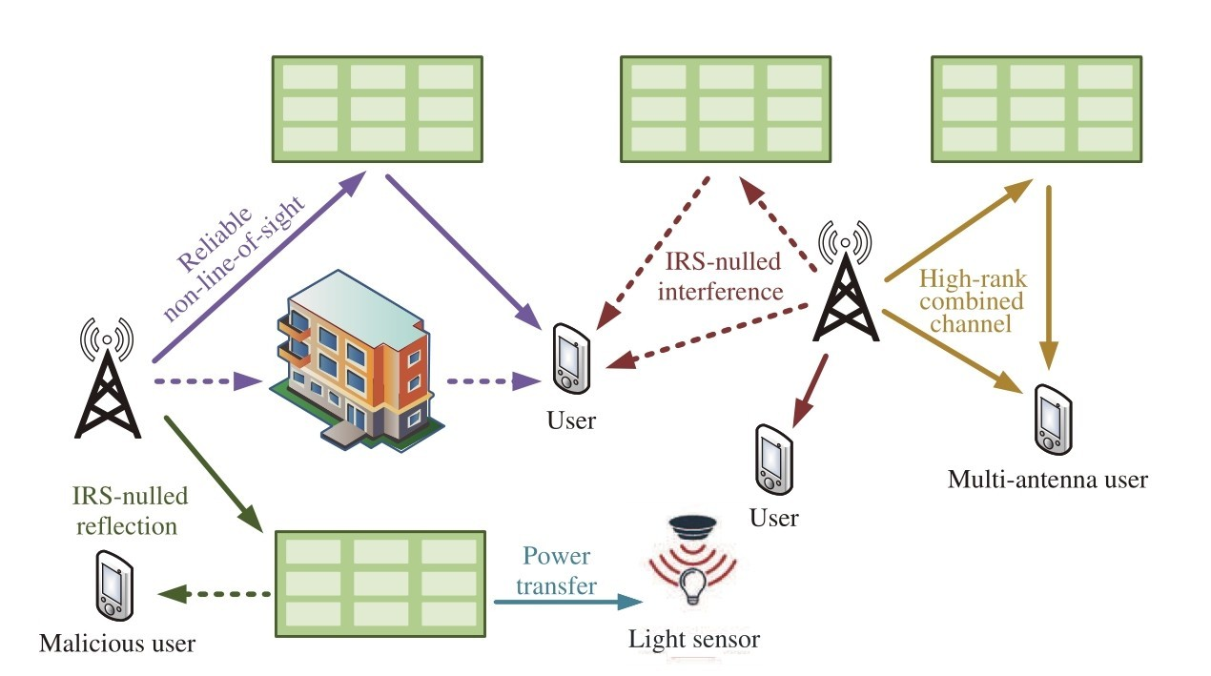

***Fig 4.3 Architecture Diagram***

**CHAPTER V**

**HARDWARE SPECIFICATION**

**5.1 Hardware**

* HDD: >90GB
* PROCESSOR: >Pentium IV 2.4GHz
* SYSTEM TYPE: 32bit / 64 bit
* RAM: >2GB
* OS: WINDOWS 7/8/8.1/10

**5.2 Specifications**

HDD: With a capacity of over 90GB, you'll have plenty of space to store your files, programs, and multimedia content without worrying about running out of storage.

Processor: A Pentium IV 2.4GHz processor or higher ensures smooth performance and responsiveness, allowing you to multitask, run demanding applications, and enjoy multimedia content with ease.

System Type: Whether you're using a 32-bit or 64-bit system, you can rest assured that your hardware will be compatible with a wide range of software and applications, giving you flexibility and versatility in your computing experience.

RAM: With over 2GB of RAM, your system will have enough memory to handle multiple tasks simultaneously, ensuring smooth multitasking and efficient performance even with resource-intensive applications.

OS: Compatible with a variety of Windows operating systems including Windows 7, 8, 8.1, and 10, you'll have access to the latest features, security updates, and compatibility with a wide range of software and hardware peripherals.

In summary, the specified hardware requirements provide a solid foundation for a versatile and capable computing experience. With ample storage space, a reliable processor, sufficient RAM, and compatibility with various Windows operating systems, users can enjoy smooth performance, multitasking capabilities, and access to a wide range of software applications.

**CHAPTER VI**

**SOFTWARE SPECIFICATION**

**6.1 Software Requirements**

* Tool: Matlab
* Toolbox: Image Processing Toolbox

**6.2 Software Specification**

MATLAB is a great and flexible tool, more than capable of performing data mining. However, it is clear that MATLAB has not been given due concentration in this arena. Figure 1.1 illustrates that, while a comparatively trendy data mining tool, MATLAB is not yet in the group of packages such as Clementine, Weka, and even Excel. In addition, though MATLAB is selected more regularly than Oracle, it is usually used in combination with other tools. Whereas Oracle is implemented as the stand-alone tool over 50% of the time, MATLAB is used on its own just over 12% of the time.

Table 1.2 summarizes the place of MATLAB over the last past 7 years. Despite MATLAB being presently capable of the stage, some of the most trendy data mining techniques existing, such as those being analyzed in this project, it has not yet become one of the groups of choice in this meadow. The popularity of these methods is detailed in Table 1.1, which is based on samples of 16 altered data mining methods over the last 4-year period from 2013 to 2016.

***Figure 1.1: 2016 Data Mining Tools Poll 1138 Votes MATLAB Ranks 10th with5% of the votes***

One cause for MATLAB’s restricted use may be the fact that is a proprietary group (or) package. However, the fundamental MATLAB package is without difficulty enhanced, mainly by using the open-source tool-boxes and the script bundles, such as those examined in this case study. The detail MATLAB’s data mining possible has positively not been entirely subjugated (as established in Figure 1.1 and Table 1.2), jointly with the current required for data mining tools, is the middle inspiration for carrying out this case study.

|  |  |  |  |  |
| --- | --- | --- | --- | --- |
| **Method** | **2013** | **2014** | **2015** | **2016** |
| **Decisiontree** | Rank:1  (15%) | Rank:1  (15%) | Rank:1  (16%) | Rank:1  (13%) |
| **Clustering** | Rank:2  (11%) | Rank:2  (11%) | Rank:3  (10%) | Rank:2  (12%) |
| **Neuralnets** | Rank:5  (8%) | Rank:4  (8%) | Rank:5  (8%) | Rank:6  (7%) |
| **Association**  **rules** | Rank:6  (7%) | Rank:7  (4%) | Rank:4  (8%) | Rank:7  (6%) |

***Table1.1:Polls of trendy Data Mining Methods2013-2016***

|  |  |  |  |  |  |  |  |
| --- | --- | --- | --- | --- | --- | --- | --- |
| **MATLAB** | **2010** | **2011** | **2012** | **2013** | **2014** | **2015** | **2016** |
| **Rank** | ∞ | 7.0 | 7.0 | 14.0 | 9.0 | 15.0 | 10.0 |
| **Percentage** | N/a | 5% | 5% | 3% | 2% | 2% | 5% |

***Table1.2:celebrity of MATLAB in Data Mining 2010-2016***

The combination of data mining tools provided in the thesis allowed for a far larger holistic technique to data mining in MATLAB than has been presented existing, and in addition, ensured that MATLAB can be used as a stand-alone tool, somewhat than in combination with former packages. These case studies ensure that data mining in MATLAB becomes a gradually more clear-cut task, as the suitable tools for a known investigation become visible. As a logical expansion of the combination provided, recommendation is given with consider the formation of a data mining toolbox for MATLAB. The opportunity for addition to this work is numerous, not only in terms of extending the tools themselves but also of data mining in MATLAB as an entire.

**Project Overview**

Due to the broad and undefined environment of this case study, it is very important that we focus on the number of exact tools and case studies. The data mining tools around which this study case will revolve are: the Neural-Network Toolbox, a proprietary tool presented from The MathWorks, distributors of MATLAB. The Fuzzy cluster and Data study Toolbox [Balasko et al. 2015] and the association Rule Miner and presumption study tool [Malone 2013], which are both open-platform; and lastly an execution of the C4.5 judgment tree method [Woolf, 2015].

**MATLAB Overview**

MATLAB is an elite dialect for specialized figuring. It incorporates calculation, perception, and programming in a simple to-use condition where issues and arrangements are communicated in commonplace numerical documentation. Typical uses incorporate:

- Math and calculation

- Algorithm improvement

- Data obtaining

- Modeling, reenactment, and prototyping

- Data investigation, investigation, and representation

- Scientific and building illustrations

- Application improvement, including graphical UI building

MATLAB is an intelligent framework whose fundamental information component is an exhibit that does not require dimensioning. This enables you to explain numerous specialized figuring issues, particularly those with grid and vector definitions, in a small amount of the time it would take to compose a program in a scalar noninteractive dialect, for example, C or Fortran. The name MATLAB remains for matrix research facility. MATLAB was initially written to give simple access to matrix programming created by the LINPACK and EISPACK ventures. Today, MATLAB motors join the LAPACK and BLAS libraries, embedding the best in class in programming for matrix calculation.

MATLAB has developed over a time of years with contribution from numerous clients. In college conditions, it is the standard instructional device for beginning and best-in-class courses in arithmetic, designing, and science. In industry, MATLAB is the device of decision for high-efficiency research, improvement, and investigation.

MATLAB highlights a group of extra application-particular arrangements called toolkits. Important to most clients of MATLAB, tool stash enables you to learn and apply specific technology. Toolkits are complete accumulations of MATLAB capacities (M-records) that expand the MATLAB condition to take care of specific classes of issues. Regions in which toolkits are accessible incorporate signal handling, control frameworks, neural networks, fuzzy logic, wavelets, re-enactment, and numerous others.

**THE MATLAB SYSTEM**

The MATLAB framework comprises of five fundamental parts:

* **Improvement Environment.** This is the arrangement of apparatuses and offices that assistance you utilize MATLAB capacities and records. A considerable lot of these instruments are graphical UIs. It incorporates the MATLAB work area and Command Window, a charge history, an editorial manager and debugger, and programs for review help, the workspace, records, what's more, the inquiry way.
* **The MATLAB Mathematical Function Library.** This is a huge gathering of computational calculations going from basic capacities, similar to total, sine, cosine, and complex number-crunching, to more advanced capacities like network backwards, framework eigen values, Bessel capacities, and quick Fourier changes.
* **The MATLAB Language.** This is an abnormal state framework/exhibit dialect with control stream proclamations, capacities, information structures, input/yield, and protest situated programming highlights. It permits both "programming in the little" to quickly make snappy discard projects, and "programming in the huge" to make substantial and complex application programs.
* **Designs.** MATLAB has broad offices for showing vectors and lattices as diagrams, and additionally commenting on and printing these charts. It incorporates abnormal state capacities for two-dimensional and three-dimensional information perception, picture handling, activity, and introduction illustrations. It too incorporates low-level capacities that enable you to completely tweak the presence of illustrations and in addition to assemble finish graphical UIs on your MATLAB applications.
* **The MATLAB External Interfaces/API.** This is a library that enables you to compose C and Fortran programs that collaborate with MATLAB. It incorporates offices for calling schedules from MATLAB (dynamic connecting), calling MATLAB as a computational motor, and for perusing and composing MAT-records.

**MATLAB DOCUMENTATION**

MATLAB gives broad documentation, in both printed and on the web design, to enable you to find out about and utilize the greater part of its highlights. In the event that you are another client, begin with this Getting Started book. It covers all the essential MATLAB highlights at an abnormal state, including numerous cases.

The MATLAB online help gives undertaking focused and reference data about MATLAB highlights. MATLAB documentation is additionally accessible in printed shape and in PDF organizes.

**MATLAB ONLINE HELP**

To see the online documentation, select MATLAB Help from the Help menu in MATLAB. The MATLAB documentation is sorted out into these principle themes:

* Desktop Tools and Development Environment — Startup and shutdown, the work area, and different devices that assistance you utilize MATLAB
* Mathematics — Mathematical tasks and information investigation
* Programming — The MATLAB dialect and how to create MATLAB applications
* Graphics — Tools and systems for plotting, diagram explanation, printing, furthermore, programming with Handle Graphics®
* 3-D Visualization — Visualizing surface and volume information, straightforwardness, and review and lighting systems
* Creating Graphical User Interfaces — GUI-building devices and how to compose callback capacities
* External Interfaces/API — MEX-documents, the MATLAB motor, and interfacing to Java, COM, and the serial port

MATLAB additionally incorporates reference documentation for all MATLAB capacities:

* Functions - By Category — Lists all MATLAB capacities assembled into classifications
* Handle Graphics Property Browser — Provides simple access to depictions of designs protest properties
* External Interfaces/API Reference — Covers those capacities utilized by the MATLAB outside interfaces, giving data on language structure in the calling dialect, portrayal, contentions, return esteems, and illustrations

The MATLAB online documentation likewise incorporates

• Examples — A record of cases incorporated into the documentation

• Release Notes — New highlights and known issues in the present discharge

• Printable Documentation — PDF forms of the documentation appropriate for printing

**MATLAB'S POWER OF COMPUTATIONAL MATHEMATICS**

MATLAB is utilized as a part of each feature of computational science. Following are a few regularly utilized scientific counts where it is utilized generally usually:

* Dealing with Matrices and Arrays
* 2-D and 3-D Plotting and illustrations
* Linear Algebra
* Algebraic Equations
* Non-straight Functions
* Statistics
* Data Analysis
* Calculus and Differential Equations
* Numerical Calculations
* Integration
* Transforms
* Curve Fitting
* Various other exceptional capacities

**HIGHLIGHTS OF MATLAB**

Following are the essential highlights of MATLAB:

* It is an abnormal state dialect for numerical calculation, representation and application advancement.
* It additionally gives an intelligent domain to iterative investigation, plan what's more, critical thinking.
* It gives immense library of numerical capacities for direct variable based math, measurements, Fourier examination, sifting, advancement, numerical coordination and comprehending standard differential conditions.
* It gives worked in illustrations to picturing information and instruments for making custom plots.
* MATLAB's customizing interface gives improvement devices for moving forward code quality, practicality, and augmenting execution.
* It gives devices to building applications with custom graphical interfaces.
* It gives capacities to coordinating MATLAB based calculations with outer applications and dialects, for example, C, Java, .NET and Microsoft Excel.

**EMPLOYMENTS OF MATLAB**

MATLAB is generally utilized as a computational device in science and building incorporating the fields of material science, science, math and all building streams. It is utilized as a part of a scope of utilizations including:

* Flag preparing and Communications
* Picture and video Processing
* Control frameworks
* Test and estimation
* Computational back
* Computational science

**CONDITION or ENVIRONMENT SETUP**

**Neighbourhood Environment Setup**

Setting up MATLAB condition involves few ticks. The installer can be downloaded from http://in.mathworks.com/downloads/web_downloads: Math Works gives the authorized item, a trial rendition and an understudy form as well. You have to sign into the site and sit tight a little for their endorsement. In the wake of downloading the installer the product can be introduced through couple of snaps.

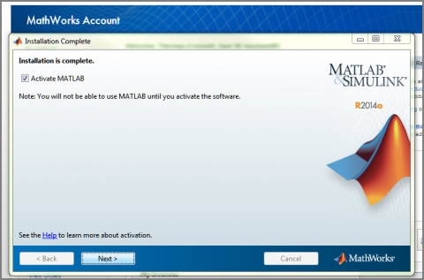

**Understanding the Matlab Environment**

MATLAB advancement IDE can be propelled from the symbol made on the work area. The principle working window in MATLAB is known as the work area. At the point when MATLAB is begun, the work area shows up in its default format:

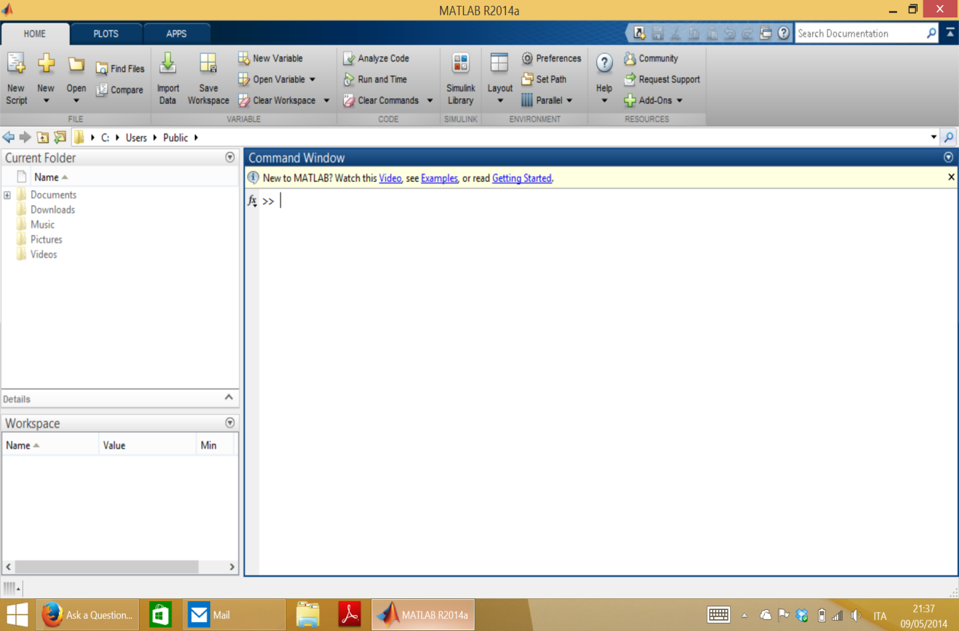

The work area has the accompanying boards:

* **Current Folder -** This board enables you to get to the task organizers and documents.

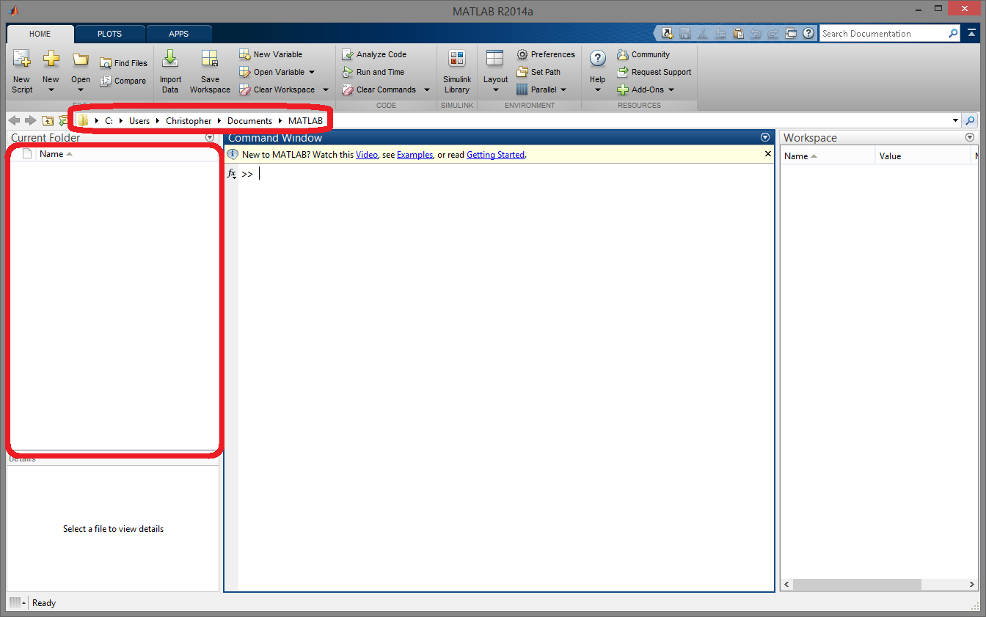

* **Order Window -** This is the principle zone where charges can be entered at the order line. It is shown by the charge incite (>>).

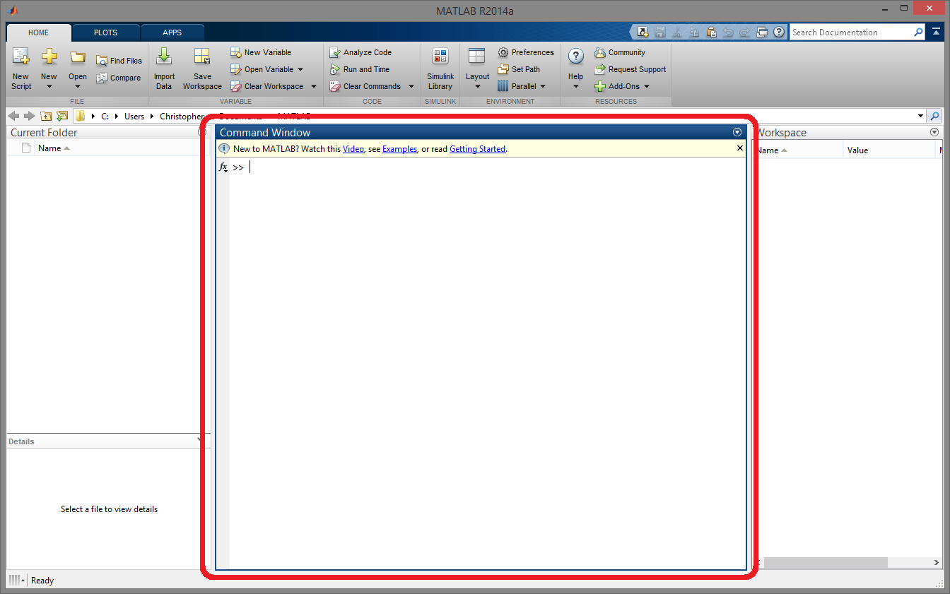

* **Workspace -** The workspace demonstrates every one of the factors made as well as transported in from documents.

* **Order History -** This board shows or rerun charges that are entered at the charge line

**1.6. Diagram of Project Chapters**

* **Part 2:** Design Considerations – Lays out the points of interest of the work done in this proposition. This part is of incredible significance in that it displays the techniques utilized as a part of both researching and combining the devices.
* **Part 3:** Tool Investigation – Begins by presenting the contextual investigations whereupon the tests did are to be constructed. Continues with the examination of each of the tool stash, delineating the examinations did and any issues experienced in this region. Basically contains preparatory discoveries of this work, which are vital for the execution of our blend of apparatuses.
* **Part 4:** Implementation and Results – Brings together the examination of the devices as the after-effects of blend are introduced and talked about.
* **Part 5:** Findings and Evaluation – A concise assessment of the outcomes introduced in Section 4 in view of other comparable contextual investigations which were done as a major aspect of the investigative procedure of this work. The after-effects of this assessment are then abridged by giving proposals respect the formation of an information digging tool compartment for MATLAB.
* **Part 6:** Conclusion and Possible Extensions – Concludes the task, exhibiting both the discoveries of this work and the numerous potential outcomes for additionally look into around there.

**1.7. Section Summary**

In this section, we have examined the bearing and points of this investigation. We have too picked up a review of MATLAB and what is required for us to accomplish as for information mining inside this bundle. It is to a great degree energizing to set out on something as new as this, especially since the work is done here couldn't just upgrade the handiness of MATLAB in performing information mining, yet in addition acquire more prominent lucidity to its place the field in general. We now leave on the advancement of the philosophy required to achieve the goals which have been laid out.

**MATLAB "GUIDE" TOOL**

**User amicable graphical interface**

As per Galitz (2002, 15, 41 - 51), a graphical UI can be characterized as set of ethos and instruments, used to make intelligent correspondence between a program and a client. The writer of the book underlines the significance of planning process by introducing fundamental tenets. Appropriate visual piece is an absolute necessity. The point is to give the client tastefully wonderful workplace. Hues, arrangement and straightforwardness of look ought to be thought about precisely. Each capacity, catch or some other question ought to have its importance, basic and justifiable by a normal program client. Comparative parts ought to have closely resembling looks and utilization. Capacities should perform rapidly and result with needed result. Adaptability can be seen in this theme as being touchy to every client's information, abilities, encounter, and individual execution furthermore, different contrasts that may happen. A decent interface is straightforward, limits the number of activities and does what it is relied upon to do. It isn't a simple assignment to plan an productive and easy to use graphical interface. Fortunately, Matlab gives an accommodating instrument called 'GUIDE'. Subsequent to writing guide into Matlab's summon line, a snappy begin window shows up. From the decision of commendable positions it is prescribed to pick 'Clear GUI'. In the new window it is conceivable to simplified each question into the region of the program. On the left half of the made figure there is a rundown of conceivable segments. The rundown incorporates a push catch, slider, tomahawks, static and alter writings – which will be depicted in points of interest in the following section. It likewise contains objects that will be quickly clarified beneath (exclusively in view of Mathworks.com):

• Toggle Button – once squeezed remains discouraged and executes an activity, after the second snap it comes back to the raised state and plays out the activity once more;

• Check Box – produces an activity when checked and shows its state (checked or on the other hand not checked), numerous choices may be ticked in a similar time;

• Radio Button – like the check box, however just a single choice can be chosen at any given time, work begins working after the radio catch is clicked;

• Listbox – shows a rundown of things and empowers client to choose at least one from them;

• Pop-up Menu – open a rundown of decisions when the bolt is squeezed; Board – bunches all parts what makes interface simple and justifiable, places of all items are with respect to the board and don't change while moving the entire board;

• Button Group – like the board however ready to oversee particular conduct of

radio and flip catches that are legitimately gathered;

• ActiveX Component – permits showing ActiveX controls that are intuitive innovation augmentations of html. They empower sound, Java applets and livelinesss to be incorporated in a Web page.

**Figure 10. Case of graphical UI with a portion of the segments**

After the first efficient, GUIDE stores the interface in two records .fig document, where the portrayal of entire realistic part is set and .m document, where the code that controls the activities can be found. Each protest properties are kept in the .fig record and can be set specifically from GUIDE apparatus, on account of prepared assembled Property Inspector. All activities, ordinarily called 'callbacks' can be altered and changed in the .m document. Each and every segment has 'Tag' property, which is utilized while making the name of the callback allude once. To gain admittance to each characteristic, Matlab offers charge set. It requires reference to the protest that is going to be changed and the name of the property, trailed by its esteem. Among different qualities, there is an activity trigger - callback task. It is imperative to know, that any component can have its own particular usage of this work. Other than activities in charge of activities of articles, there are two extra capacities actualized in .m record:

• Opening capacity – executes errands before the interface ends up unmistakable to the client;

• Output work – if necessary, it returns factors to the order line. There is considerably more behind instruments and procedures of programming GUI however this point will be clarified nearly in the following section.

**Main parts of GUI**

**Common information**

All agent UI segments of Matlab GUI are called 'uicontrols'. They all contain different choices of properties to be set. After a developer double taps a protest made in GUIDE, a window of Property Inspector shows up. It is a rundown of all alterable attributes of the segment, spoke to by Figure 7, beneath.

**Fig 11: property inspector**

The majority of GUIDE controls have basic properties, in charge of similar attributes of a part. What's more every protest has a few supplementary highlights. Each property can be questioned with order get and changed by summon set, as specified previously. To start with gathering of characteristics is in charge of control of visual style and appearance.'Backgroundcolor' characterizes shade of the rectangle of the uicontrol. Likewise, 'Foregroundcolor' sets tinge of the string that figures on the catch. Critical field 'CData ' permits to put a truecolor picture on the catch rather than the content. Parameter 'String ‘places given word on the catch. Line 'Obvious' can take either on or off esteem, the protest can be unmistakable or not. Indeed, even not seen, regardless it exists and permits getting all the data about it.Next accumulation of properties concerns data about the question. 'Empower' characterizes on the off chance that the catch is on, off or idle. Choice ON states that uicontrol is operational. Individually, elective OFF, states inability of continuing any activity on the catch. In this case mark is turned gray out. Choosing idle esteem permits indicating segment as empowered, however in genuine, it isn't working. The sort of uicontrol is chosen by 'Style' field. Conceivable estimations of this parameter are: pushbutton, toggle button, radio button, checkbox, alters, content, slider, Listbox and popup menu. Each made question has its name, put away in 'Tag' property. It helps with keeping up the application and explores among the segments. Another valuable trait is 'Tooltip String'. Each time a client rolls a mouse over the uicontrol and abandons it there, a content set in this place is appeared. Those little clues can be useful on the off chance that question isn't totally reasonable. Last component from this gathering is 'User Data'. It permits associating any information with the part and can be come to with get work. Third classification manages situating, textual styles and names. 'Position' parameter is dependable for arrangement of the protest. It requires four esteems which are: the lower left corner of the part (separate from the edge of the figure) and its stature and width. 'Units' field is utilized by Matlab for estimations and elucidation of separation. Feasible qualities can be inches, centimetres, focuses, pixels and characters. Pixels are default setting. There is couple of text style properties. With them a software engineer can choose 'Font Angle' (ordinary, italics or diagonal), 'Font Name' (text style family), 'Font Size' and 'Font Weight' (light, ordinary, demy or intense). Parameter 'Horizontal Alignment' decides the avocation of the content of the 'String' property. Potential outcomes to set are cleared out, right and focus. Last gathering of properties considers all activities performed by the application. Characteristic 'ButtonDownFcn' executes callback work at whatever point a client presses the mouse catch while the pointer is close or in five extensive outskirt around the part. There is a field named 'Callback' containing a reference to either M-document or legitimate Matlab articulation. At whatever point a protest is enacted, a callback capacity will be executed. Two next highlights – 'CreateFcn' and 'DeleteFcn' work in the path inverse to each other. Initial one determines a callback schedule that performs activity when Matlab makes a uicontrol. Separately, second attribute begins an activity each time uicontrol protest is decimated. This trademark is certainly a benefit, in light of the fact that a developer can set a few activities just before a segment will be expelled from the application. A more complex field, called 'Interruptible', contains data concerning activities activated by the client, amid executing of one of callback capacities. This property can go up against or off esteem. In the primary case, Matlab will enable second task to hinder initial one. As needs be, if off is the chosen alternative, the principle callback won't be meddled. There are properties vital just for specific uicontrols. Next four sections will quickly portray a portion of the parts and their extra highlights.

**Buttons and Sliders**

Push catches are critical parts since they enable a client to connect with the program on a visual and straightforward level. Normally catches are suggestive and they pass on their primary reason. With regards to sliders, they are not less profitable than catches. Because of sliders, clients can change for instance shine or complexity of the picture, with some specific advances. Field 'Style' takes contention pushbutton or slider, trustworthy from the kind of uicontrol. There are four parameters, associated together. 'Min' and 'Max' indicate the base and most extreme slider esteems. Defaults are 0 for least what's more, 1 for most extreme. Matlab won't permit characterizing the most minimal number greater than expected most extreme numeral. Utilizing the two properties, 'Slider Step' trait can be resolved. As the name recommend, this trademark computes the span of the progression which a client may alter, by clicking bolts on this part. The progression of the slider is a two component vector. As a matter of course it breaks even with the section [0,01 0,1], which sets one percent change for taps on the bolt catch and 10% alteration for clicks in the center. Additionally highlight 'Esteem' depends on past numbers. It is set to the point, demonstrated by the slider bar and a software engineer can get to it with get work.Figure 8 demonstrated as follows, speaks to model Property Inspector for a slider bar.

**Figure 12. An example of Property Inspector for a slider bar**

**Axes**

Tomahawks segment contains a few extra qualities. 'Box' property characterizes whether the district of the tomahawks will be encased in two – dimensional or three – dimensional region. Choices 'XTick', 'XTick Label' and 'YTick', 'YTick Label' permit a software engineer to characterize what esteems will be shown along the level and vertical pivot. As a separator, the simplest route is to utilize this line '|'. Likewise the area of the two lines can be set with help of 'XAxis Location' and 'Y-axis Location' highlights. 'X Grid' and 'Y Grid' makes the network that may be helpful while editing or resizing handled picture (Marchand&Holland, 2003, 248-283).Other than every single graphical trait in charge of external look of the tomahawks, this protest contains additionally all highlights basic for various parts. Considerable measure of properties won't be portrayed here on the grounds that they allude to appearance of charts, drawn with plot summon, while this project treats about picture handling.In this manner, tomahawks will be utilized as a territory of picture information and show. Figure 9 shows Property Inspector for an interface part - tomahawks.

**Fig 13: An example of property inspector for axes**

**Creating menu**

Each respectable application ought to have the menu bar. A normal PC client is acclimated to plausibility of completing most things the assistance of the menu. That is why Matlab empowers software engineers to make two sorts of menus:

• Menu bar objects – drop-down menus whose titles are arranged on the highest point of the figure;

• Context menu objects – fly down menus that show up after a client right – click one of the segments. To make them two, GUIDE offers Menu Editor. They are executed with two objects – submenu and uicontextmenu. Subsequent to entering GUIDE Menu Editor it is conceivable to make a progressive menu, without any restrictions of things sum. This instrument helps developers on numerous levels. Procedure of making menu winds up instinctive and basic. It empowers setting of menu properties with Property Inspector, for each menu and submenu component. Making setting menu requires changing the tab into 'Setting Menus'. At that point the procedure goes additionally to the menu bar building. There are a few properties that can be set just after new menu is produced. 'Name' characterizes the name of the thing that will be shown to the client. 'Tag' esteem decides the name, expected to recognize the callback work. 'Separator over this thing' is in charge of a thin line between intelligently separated menu components. Another property 'Check stamp this thing' shows a check beside the menu thing and shows the present condition of this thing. To guarantee that clients can choose any choice, property 'Empower this thing' must be checked. (Marchand&Holland, 2003, 432-440).Menu Editor is exhibited in Figure 10, underneath.

**Figure 15. An exemplary menu created in Menu Editor**

Next I will portray the properties of the menu. These depictions are exclusively in light of Marchand&Holland (2003, 434 – 440) book, section tenth. The 'Quickening agent' field characterizes the console equal that a client can press to actuate specific submenu protest. Nearness of the alternate ways is significant expansion to the GUI. On account of them the time and exertion of activity is diminished. Arrangement Ctrl + Accelerator choose the menu thing. Just things that don't have a submenu can be associated with some alternate way. 'Callback' is already disclosed reference to the capacity that plays out an activity. At whatever point a menu thing has a submenu, all components from that point are alled 'youngsters' of the said thing. Parameter 'Kids' records all submenu components in a segment vector. On the off chance that there is no 'youngsters', the field turns into a void lattice. Another component chooses if a choice is accessible to the client. On the off chance that it isn't then 'Empower' esteem is set to off. All things considered, the name of the menu thing is darkened and shows that it isn't conceivable to choose it. For more pleasant visual impact, a software engineer can change the textual style shade of the menu names with 'Foregroundcolor' quality. With regards to the setting menu, just a single alternative is in charge of it. 'Uicontextmenu' as a default, takes 'none' parameter. In the event that the setting menu was made previously, its name ought to show up in the rundown of alternatives. In the wake of choosing it, a client can appreciate right– click menu for the given part. Figure 11 presents prepared constructed menu.

**Fig16: simple, GUI with Ready –built menu**

**CHAPTER VII**

**RESULTS**

The results of implementing the proposed system for wireless channel estimation utilizing Deep Learning (DL) techniques are discussed herein. Through experimentation and evaluation, the performance of the system in various scenarios and conditions is thoroughly examined. Firstly, the effectiveness of the RESNET50 architecture for channel estimation is evaluated. RESNET50, known for its deep learning capabilities and proven performance in image classification tasks, is utilized as the backbone architecture for the channel estimation models. Through extensive experimentation, it is observed that RESNET50 demonstrates promising results in accurately estimating channel characteristics across different frequency bands, wireless resources, and geographical environments. The deep convolutional neural network (CNN) structure of RESNET50 enables it to effectively capture complex patterns and features from input data, resulting in improved channel estimation accuracy compared to traditional methods.

Next, the impact of training set acquisition strategies on the performance of the DL models is investigated. The proposed dataset strategy, comprising a diverse range of samples including benchmark training, meta-learning, and fine-tuning sets, proves to be effective in enhancing the robustness and adaptability of the DL models. By incorporating conventional training techniques such as VGG16, the DL models demonstrate improved generalization capabilities and better performance in real-world communication scenarios. Furthermore, the comprehensive dataset strategy ensures that the DL models are capable of accurately estimating channel characteristics across a wide range of communication scenarios, including varying frequency bands, wireless resources, and geographical conditions.

The adaptability of the proposed system to the 6G era is also evaluated. With the introduction of new technologies such as millimeter-wave communication, massive MIMO, and intelligent reflecting surfaces, the need for robust and adaptable channel estimation techniques becomes increasingly important. The DL-based approach proposed in this system demonstrates promising results in addressing the challenges posed by the 6G era. By leveraging DL techniques, the proposed system is capable of accommodating diverse frequency bands and wireless resources, thereby ensuring reliable and efficient communication in modern communication networks.

Moreover, the effectiveness of advanced DL techniques such as transfer learning and federated learning is examined. Transfer learning enables the reuse of pre-trained model parameters from related tasks, accelerating the training process and improving model performance. Through experimentation, it is observed that transfer learning significantly improves the convergence speed and accuracy of the DL models for channel estimation. Similarly, federated learning facilitates cooperative learning across decentralized devices or servers, enabling the aggregation of knowledge from diverse sources without centralized data collection. By leveraging federated learning, the proposed system demonstrates improved scalability and efficiency in large-scale and dynamic communication networks.

Overall, the results demonstrate the effectiveness of the proposed system for wireless channel estimation utilizing DL techniques. The RESNET50 architecture proves to be effective in accurately estimating channel characteristics across various communication scenarios. The comprehensive dataset strategy ensures the robustness and adaptability of the DL models, while advanced DL techniques such as transfer learning and federated learning further enhance the performance and scalability of the system. Through experimentation and evaluation, it is evident that the proposed system offers a promising approach to address the challenges of wireless channel estimation in the 6G era and beyond, paving the way for the development of more efficient and reliable communication systems.

**CHAPTER VIII**

**CONCLUSION AND FUTURE SCOPE**

**8.1 Conclusion**

In conclusion, this paper has shed light on the significance of integrating Deep Learning (DL) techniques into wireless channel estimation systems, particularly in the context of the evolving 6G era. Through an exploration of DL model selection, training set acquisition, and architectural design considerations, we have demonstrated the potential of DL to address the complex challenges facing modern communication networks. We have shown that traditional channel estimation methods often fall short in capturing the dynamics and heterogeneity of real-world communication environments. DL presents a promising alternative, leveraging its ability to learn patterns and extract features from large datasets to enhance the accuracy and reliability of channel estimation. The proposed methodologies, including the adoption of the RESNET50 architecture and the exploration of advanced DL techniques such as transfer learning and federated learning, offer practical solutions to improve the scalability and efficiency of wireless channel estimation systems. By incorporating these techniques, we aim to enhance the adaptability of channel estimation models across diverse frequency bands, wireless resources, and geographical conditions. Furthermore, this paper underscores the importance of collaboration and knowledge-sharing among MIMO communication researchers and practitioners. By providing practical insights and recommendations for integrating DL techniques into channel estimation applications, we aim to empower stakeholders to navigate the complexities of modern communication networks and drive innovation in the field. Looking ahead, further research and experimentation are needed to fully unlock the potential of DL in wireless channel estimation. As communication technologies continue to evolve and new challenges emerge, DL offers a versatile framework to address the evolving needs of communication systems in the 6G era and beyond. Through continued collaboration and innovation, we can realize the promise of DL in revolutionizing wireless communication and shaping the future of connectivity.

**8.2 Future Scope**

In the quest for continual improvement and innovation, several avenues for future enhancements in the integration of Deep Learning (DL) into wireless channel estimation systems stand out. One potential direction lies in the refinement of DL architectures tailored specifically for the unique characteristics of wireless communication channels. Developing architectures that can effectively handle dynamic channel conditions, varying signal-to-noise ratios, and interference scenarios could significantly enhance the accuracy and robustness of channel estimation models. Another promising area for enhancement is the exploration of novel DL techniques and algorithms that leverage additional contextual information. Integrating information such as user mobility patterns, environmental conditions, and network topology into DL models could lead to more adaptive and context-aware channel estimation systems. This approach holds the potential to improve performance in dynamic and heterogeneous communication environments.

Furthermore, the advancement of hardware accelerators optimized for DL inference could greatly enhance the efficiency and scalability of channel estimation systems, particularly in resource-constrained scenarios. By developing specialized hardware tailored for DL tasks, researchers can unlock new possibilities for real-time channel estimation in various applications, from IoT devices to massive MIMO systems.

Moreover, exploring the synergy between DL and other emerging technologies such as blockchain and edge computing could open up new avenues for collaborative and distributed channel estimation approaches. By harnessing the collective intelligence of decentralized networks, future enhancements could enable more resilient, adaptive, and secure wireless communication systems, paving the way for the next generation of connectivity.

**REFERENCES**

1. W. Yang, M. Li and Q. Liu, "A Practical Channel Estimation Strategy for XL-MIMO Communication Systems," in IEEE Communications Letters, vol. 27, no. 6, pp. 1580-1583, June 2023, doi: 10.1109/LCOMM.2023.3266821.
2. C. Poongodi, D. Deepa, K. Shoukath Ali, D. Muthumanickam and T. Perarasi, "Channel Estimation of XL-MIMO in 6G Communication System - Near Field Analysis," 2023 Third International Conference on Smart Technologies, Communication and Robotics (STCR), Sathyamangalam, India, 2023, pp. 1-4, doi: 10.1109/STCR59085.2023.10396963.
3. S. Han, P. Zhu, J. Li and Y. Wang, "Channel Estimation and Receiver Design for URLLC in Distributed MIMO-NOMA Systems Uplink," 2023 IEEE/CIC International Conference on Communications in China (ICCC), Dalian, China, 2023, pp. 1-5, doi: 10.1109/ICCC57788.2023.10233402.
4. S. G. Daware, P. Engineer and S. N. Shah, "A review on Beamspace Channel Estimation Algorithms in Wireless Communication," 2023 IEEE 7th Conference on Information and Communication Technology (CICT), Jabalpur, India, 2023, pp. 1-5, doi: 10.1109/CICT59886.2023.10455367.
5. M. Sun, S. Ren and W. Zhou, "Deep Learning Enhanced Channel Estimation of Massive MIMO mmWave Communication with One-Bit ADCs," GLOBECOM 2023 - 2023 IEEE Global Communications Conference, Kuala Lumpur, Malaysia, 2023, pp. 5817-5822, doi: 10.1109/GLOBECOM54140.2023.10437627.
6. J. Yang, X. Gong, B. Ai and W. Chen, "A Priori Based Deep Unfolding Method for mmWave Channel Estimation in MIMO Radar Aided V2X Communications," ICC 2023 - IEEE International Conference on Communications, Rome, Italy, 2023, pp. 2946-2951, doi: 10.1109/ICC45041.2023.10279126.
7. R. He and W. Zhou, "Channel Estimation for Massive MU-MIMO Systems with Real Image Denoising Network," 2022 7th International Conference on Computer and Communication Systems (ICCCS), Wuhan, China, 2022, pp. 513-518, doi: 10.1109/ICCCS55155.2022.9845979.
8. P. Zheng, X. Lyu and Y. Gong, "Trainable Proximal Gradient Descent-Based Channel Estimation for mmWave Massive MIMO Systems," in IEEE Wireless Communications Letters, vol. 12, no. 10, pp. 1781-1785, Oct. 2023, doi: 10.1109/LWC.2023.3294184.
9. E. Vlachos, C. Mavrokefalidis and K. Berberidis, "Channel Estimation for UAV-based mmWave Massive MIMO Communications with Beam Squint," 2022 30th European Signal Processing Conference (EUSIPCO), Belgrade, Serbia, 2022, pp. 1696-1700, doi: 10.23919/EUSIPCO55093.2022.9909709.
10. P. Gu, Y. Song and C. Liu, "Channel Estimation of mmWave Massive MIMO System Based on Manifold Learning," 2022 IEEE 22nd International Conference on Communication Technology (ICCT), Nanjing, China, 2022, pp. 1004-1008, doi: 10.1109/ICCT56141.2022.10073197.
11. M. Ye, X. Liang, C. Pan, Y. Xu, M. Jiang and C. Li, "Channel Estimation for mmWave Massive MIMO Systems Using Graph Neural Networks," 2023 IEEE/CIC International Conference on Communications in China (ICCC), Dalian, China, 2023, pp. 1-5, doi: 10.1109/ICCC57788.2023.10233621.
12. J. Zhang, Y. Xue, J. Wang and Y. Qi, "A Parallelized Algorithm for Channel Estimation in mmWave Massive MIMO Communications," 2022 IEEE 8th International Conference on Computer and Communications (ICCC), Chengdu, China, 2022, pp. 26-30, doi: 10.1109/ICCC56324.2022.10065999.
13. A. Doshi and J. G. Andrews, "One-Bit mmWave MIMO Channel Estimation Using Deep Generative Networks," in IEEE Wireless Communications Letters, vol. 12, no. 9, pp. 1593-1597, Sept. 2023, doi: 10.1109/LWC.2023.3283926.
14. J. Chu, Y. Guan, Y. Cheng, H. Lin and Z. Yu, "PARAFAC-Based Channel Estimation and Positioning in Millimeter-Wave Massive MIMO-OFDM Systems," 2023 International Conference on Culture-Oriented Science and Technology (CoST), Xi’an, China, 2023, pp. 96-100, doi: 10.1109/CoST60524.2023.00028.
15. Z. Dai, R. Li, J. Xu, Y. Zeng and S. Jin, "Rate-Region Characterization and Channel Estimation for Cell-Free Symbiotic Radio Communications," in IEEE Transactions on Communications, vol. 71, no. 2, pp. 674-687, Feb. 2023, doi: 10.1109/TCOMM.2022.3227237.
16. Z. Qiu, P. Zhu, J. Li, Y. Jiang and Y. Wang, "Low-Latency Channel Estimation for mmWave Massive MIMO-OFDM Systems Based on Beam-Delay Domain Pattern," 2023 IEEE 23rd International Conference on Communication Technology (ICCT), Wuxi, China, 2023, pp. 546-551, doi: 10.1109/ICCT59356.2023.10419590.
17. G. Zhu, Y. Xia and S. Li, "VBI-based Uplink Channel Estimation for Massive MIMO Systems," 2022 IEEE 5th International Conference on Electronic Information and Communication Technology (ICEICT), Hefei, China, 2022, pp. 91-95, doi: 10.1109/ICEICT55736.2022.9909288.
18. W. Belaoura, K. Ghanem, M. Nedil and H. Bousbia-Salah, "On the Impact of Hardware Impairments on mm-Wave MIMO Underground Channel Estimation," 2022 7th International Conference on Image and Signal Processing and their Applications (ISPA), Mostaganem, Algeria, 2022, pp. 1-5, doi: 10.1109/ISPA54004.2022.9786293.
19. E. Vlachos, C. Mavrokefalidis and K. Berberidis, "Velocity-aided Channel Estimation for Spatially Selective mmWave Massive MIMO Communications," 2023 31st European Signal Processing Conference (EUSIPCO), Helsinki, Finland, 2023, pp. 1455-1459, doi: 10.23919/EUSIPCO58844.2023.10289899.
20. S. Swapna and M. Ramarakula, "Modified Simultaneous Weighted – OMP Based Channel Estimation and Hybrid Precoding for Massive MIMO Systems," 2022 International Conference on Wireless Communications Signal Processing and Networking (WiSPNET), Chennai, India, 2022, pp. 221-225, doi: 10.1109/WiSPNET54241.2022.9767131.
21. S. Gherekhloo, K. Ardah, A. L. F. De Almeida, M. Maleki and M. Haardt, "Nested PARAFAC Tensor-Based Channel Estimation Method for Double RIS-Aided MIMO Communication Systems," 2023 31st European Signal Processing Conference (EUSIPCO), Helsinki, Finland, 2023, pp. 1674-1678, doi: 10.23919/EUSIPCO58844.2023.10290107.
22. R. Chen, J. He, J. Cao, H. Lin and Z. Yu, "A Novel Near-Field Channel Estimation Method for RIS-Assisted UM-MIMO Systems," 2023 International Conference on Culture-Oriented Science and Technology (CoST), Xi’an, China, 2023, pp. 277-281, doi: 10.1109/CoST60524.2023.00063.
23. C. Gong and D. Hu, "A GAN-Based Channel Estimation Method for MIMO OFDM Systems," 2023 8th International Conference on Communication, Image and Signal Processing (CCISP), Chengdu, China, 2023, pp. 410-415, doi: 10.1109/CCISP59915.2023.10355797.
24. S. Li, J. Li, H. Dong and Z. Li, "A Massive MIMO Channel Estimation Algorithm Design Combined the SVD Method with LS Signal Detection," 2022 IEEE MTT-S International Wireless Symposium (IWS), Harbin, China, 2022, pp. 1-3, doi: 10.1109/IWS55252.2022.9977532.
25. K. Shi, Z. Dai and Y. Zeng, "Dynamic AP Association for UAV-Centric Aerial-Ground Communication with Cell-Free Massive MIMO," 2023 International Conference on Communications, Computing and Artificial Intelligence (CCCAI), Shanghai, China, 2023, pp. 139-144, doi: 10.1109/CCCAI59026.2023.00033.